**PAPER KNIGHTS**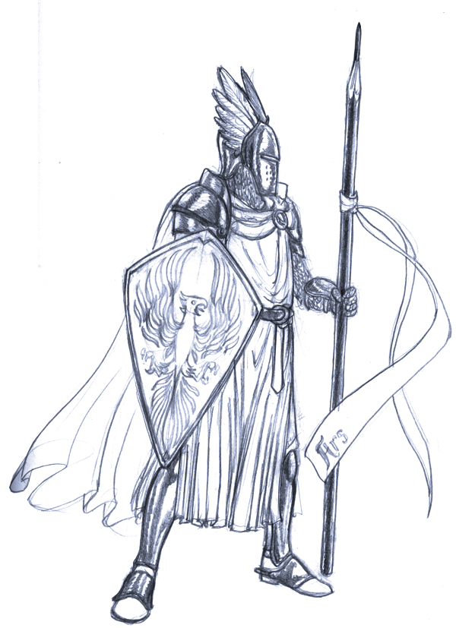

OBJECTIVE:

The goal of the game is to capture the opponent's King while keeping your own safe. You win when you place your unit on a tower space and the revealed card beneath is the King

GAME SETUP:

Shuffle the Event cards, each player gets a Divine Favor

Players alternate selecting retainers until each has 8 (4 each for 4 players)

Place troops in the Keep.

Place your King and the 2 Decoy cards under the 3 towers face down.

START OF GAME:

Person with the longest full name has the choice of going first. Ties are resolved via Thumb War.

The first turn is taken with a -1 reduction to the unit’s movement.(min movement of 1)

They must move a unit onto the board through one of the 4 gates.

MANEUVER 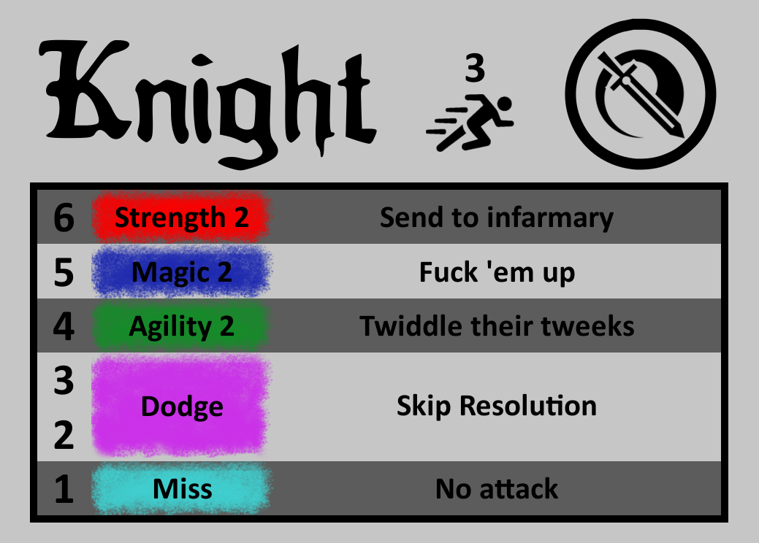

You may either move a unit or engage in combat.

You may do only one or both.

But you must do at least one.

If you are in a position where you can’t do either than you lose the game.

MOVEMENT:

You may move one unit a turn. A unit’s movement is listed on their ability card next to their name.

All units must enter the field through a Gate.(This costs one point of movement)

You may not pass through/over units.(unless stated by an ability or event card)

You may place a unit on your own Tower as a defense.

You may place your unit on an opponent's Gate. They cannot move units through that gate while it's occupied.

Movement is made in a single direction(You cannot double back in the same movement.)

COMBAT:

You may engage in combat with an adjacent enemy unit ONCE per turn.

You may only attack with one unit on your turn.

When attacking the two units roll a die.This will dictate what action on it's ability card it will perform.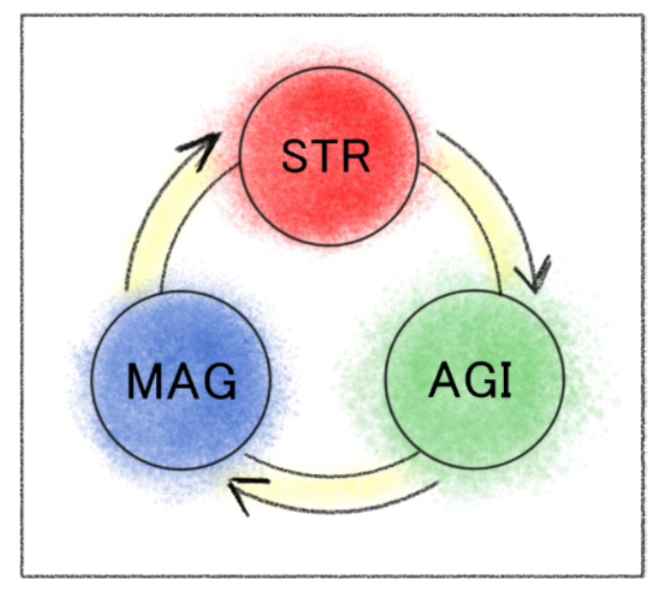

You may discard a card to increase the number on a dice roll.

* STR vs STR : The higher value wins.
* STR vs MAG: MAG performs the ability on card.
* AGI vs MAG: AGI wins.
* AGI vs AGI: The higher value wins.
* MAG vs MAG: The higher value wins.
* MAG, AGI, STR vs BLOCK: No action

If there is a tie no actions resolve

(Unless stated by ability)

EVENT CARDS:

Each player starts with a Divine Favor card.

3 event cards are shown, forming a card pool. [ 1 ] [ 2 ] [ 3 ]

When one is picked place a new one from the deck at the head of the pool.

If one was drawn from deck, then discard the one at the end and add a new card to the pool.

The first time a player ends on the Middle Space[Dragon/Oracle?] draw a card.

You may draw a card when the opponent exposes your empty tower.

You may only play a card at the beginning of your turn.

Cards may be discarded to increase your dice roll by 1.

INFIRMARY:

You may only have two units in your Infirmary at any time.

Once a third unit would be added remove the unit that has been there the longest and place it in your Keep.

TURN PHASES:

1. Play an Event Card
2. Move
3. Combat
4. End of turn

Abilities:

Mage: May only use it once per turn (On your own turn)

Knight: debuffs movement until that unit moves again(to a min of one)

Ranger: Can still be knocked out in ranged combat

Gleeman: Allies must start their movement adjacent to Gleeman to get buff

Pirate: Vs Team-- roll for random player then random card

Wizard:

Priest:

WILD 2

Adding effects like

6- Magic and can’t die

Str2 or Dodge

What outcomes do i want and how likely do i want them to occur